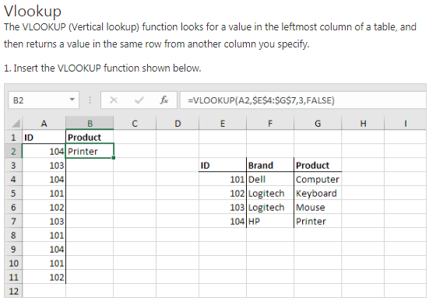

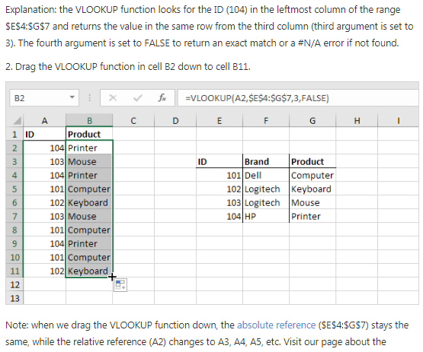

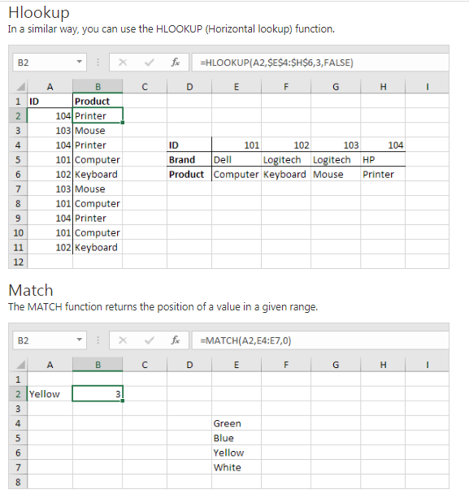

Explanation: Yellow found at position 3 in the range E4:E7. The third argument is optional. Set this argument to 0 to return the position of the value that is exactly equal to lookup_value (A2) or a #N/A error if not found.

